**Java Programming Lab:**

1. Write a Java program to print the following triangle of numbers.

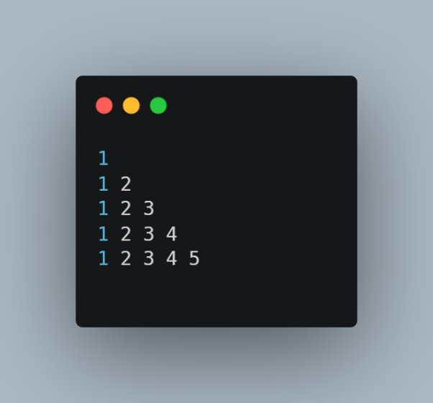

1. Write a Java program to list the **factorial** of the numbers 1 to 10. To calculate the factorial value use while loop. (Hint Fact of 4=4*3*2*1).
2. Write a Java program

* To find the **area** and **circumference** of the circle by accepting the radius from the user
* To accept a number and find whether the number is **Prime or not**.

1. Write a Java program to demonstrate a division by zero **exception**.